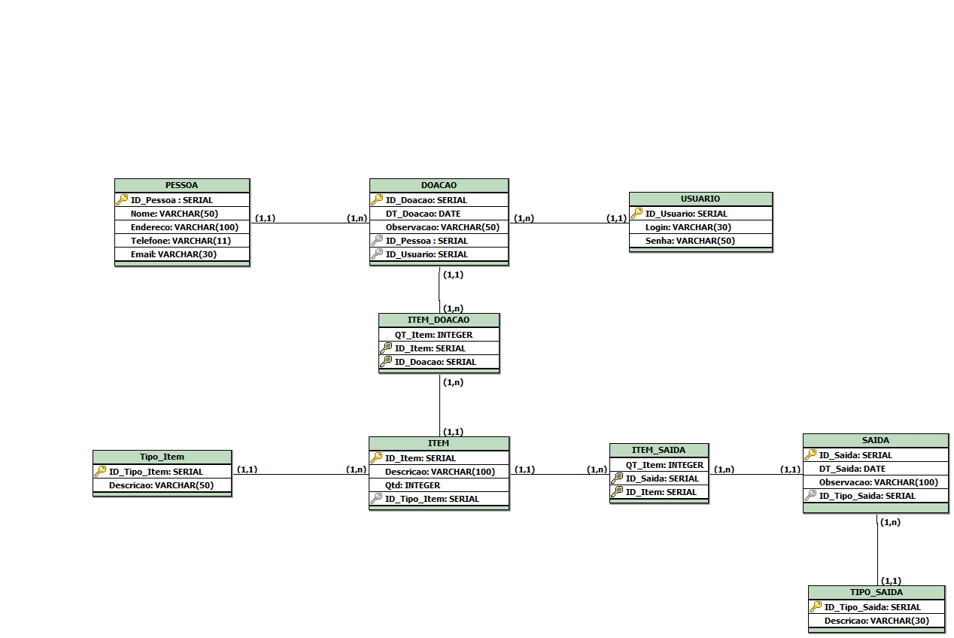

CREATE TABLE PESSOA (
ID_Pessoa SERIAL PRIMARY KEY,
Nome VARCHAR(50),
Endereco VARCHAR(100),
Telefone VARCHAR(11),
Email VARCHAR(30)
);

CREATE TABLE Tipo_Item (
ID_Tipo_Item SERIAL PRIMARY KEY,
Descricao VARCHAR(50)
);

CREATE TABLE TIPO_SAIDA (
ID_Tipo_Saida SERIAL PRIMARY KEY,
Descricao VARCHAR(30)
);

CREATE TABLE SAIDA (
ID_Saida SERIAL PRIMARY KEY,
DT_Saida DATE,
Observacao VARCHAR(100),
ID_Tipo_Saida INTEGER,
FOREIGN KEY(ID_Tipo_Saida) REFERENCES TIPO_SAIDA (ID_Tipo_Saida)
);

CREATE TABLE USUARIO (
ID_Usuario SERIAL PRIMARY KEY,
Login VARCHAR(30),
Senha VARCHAR(50)
);

CREATE TABLE DOACAO (
ID_Doacao SERIAL PRIMARY KEY,
DT_Doacao DATE,
Observacao VARCHAR(50),
ID_Pessoa INTEGER,
ID_Usuario INTEGER,
FOREIGN KEY(ID_Pessoa ) REFERENCES PESSOA (ID_Pessoa),
FOREIGN KEY(ID_Usuario) REFERENCES USUARIO (ID_Usuario)
);

CREATE TABLE ITEM (
ID_Item SERIAL PRIMARY KEY,
Descricao VARCHAR(100),
Qtd INTEGER,
ID_Tipo_Item INTEGER,
FOREIGN KEY(ID_Tipo_Item) REFERENCES Tipo_Item (ID_Tipo_Item)
);

CREATE TABLE ITEM_DOACAO (
QT_Item INTEGER,
ID_Item INTEGER,
ID_Doacao INTEGER,
PRIMARY KEY(ID_Item,ID_Doacao),
FOREIGN KEY(ID_Item) REFERENCES ITEM (ID_Item),
FOREIGN KEY(ID_Doacao) REFERENCES DOACAO (ID_Doacao)
);

CREATE TABLE ITEM_SAIDA (
QT_Item INTEGER,
ID_Saida INTEGER,
ID_Item INTEGER,
PRIMARY KEY(ID_Saida,ID_Item),
FOREIGN KEY(ID_Item) REFERENCES ITEM (ID_Item),
FOREIGN KEY(ID_Saida) REFERENCES SAIDA (ID_Saida)
);

